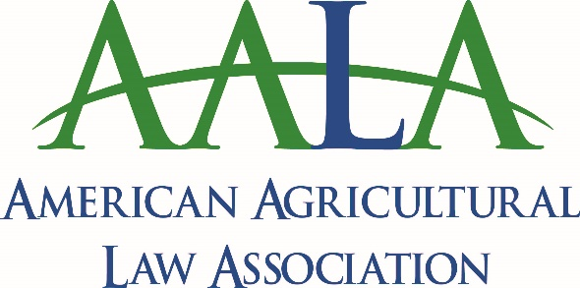

2020 AALA Symposium Sponsorship Levels and Benefits**

Platinum: $20,000+
- 10 Complimentary Registrations
- 10 Complimentary 2020-2021 AALA Memberships (Membership Year is June 1 – May 31)
- Sponsor Designation on Badge
- Exhibit Space
- Recognition on Program, Website, Member Communications and all Conference Materials

Diamond: $15,000 - $19,999
- 8 Complimentary Registrations
- 8 Complimentary 2020-2021 AALA Memberships (Membership Year is June 1 – May 31)
- Sponsor Designation on Badge
- Exhibit Space
- Recognition on Program, Website, Member Communications and all Conference Materials

Gold: $10,000 - $14,999
- 6 Complimentary Registrations
- 6 Complimentary 2020-2021 AALA Memberships (Membership Year is June 1 – May 31)
- Sponsor Designation on Badge
- Exhibit Space
- Recognition on Program, Website, Member Communications and all Conference Materials

Silver: $5,000 - $9,999
- 3 Complimentary Registrations
- 3 Complimentary 2020-2021 AALA Memberships (Membership Year is June 1 – May 31)
- Sponsor Designation on Badge
- Exhibit Space
- Recognition on Program, Website and Member Communications

Bronze: $2,500 - $4,999
- 2 Complimentary Registration
- 2 Complimentary 2020-2021 AALA Memberships (Membership Year is June 1 – May 31)
- Sponsor Designation on Badge
- Exhibit Space
- Recognition on Program and Website

AALA Contributor: $1,000-$2,499
- 1 Complimentary Registration
- Sponsor Designation on Badge
- Exhibit Space
- Recognition on Program and Website

Friend of AALA: $100-$1,000
- Recognition on Program and Website

CLE Event Sponsorships:
- Break: $5,000 or more (4 available)
- Breakfast: $10,000 or more (2 available)
- Lunch: $15,000 or more (1-2 available)
- Reception: $20,000 or more (2 available)
- Hospitality Suite: TBD
- Student activities/registration (no maximum number): $100+

**Sponsors are welcome to combine with one another for joint sponsorship.

